**SUGAR**

**HERO**

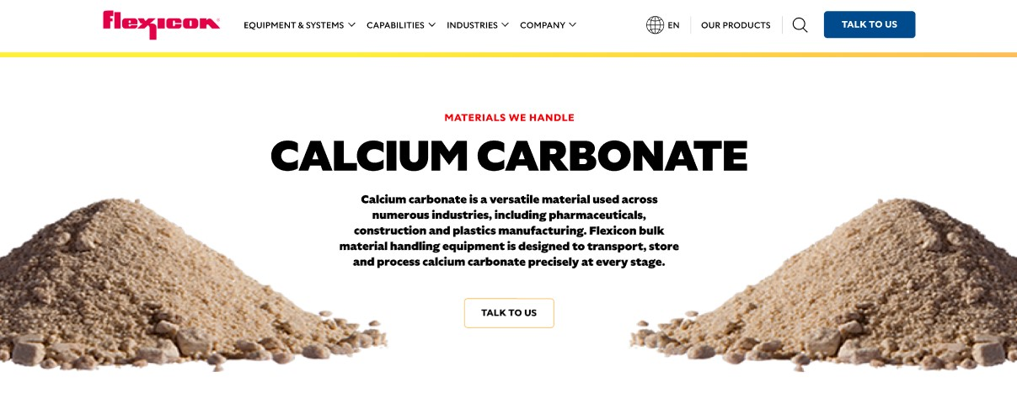

Sugar is a foundational ingredient in food and beverage production, valued for its flavor, texture, and preservative qualities. Flexicon bulk material handling equipment ensures safe, efficient, and precise movement of sugar throughout your processing operations.

**Button**: Talk To Us

**SHELF #1 - PRODUCT DESCRIPTION**

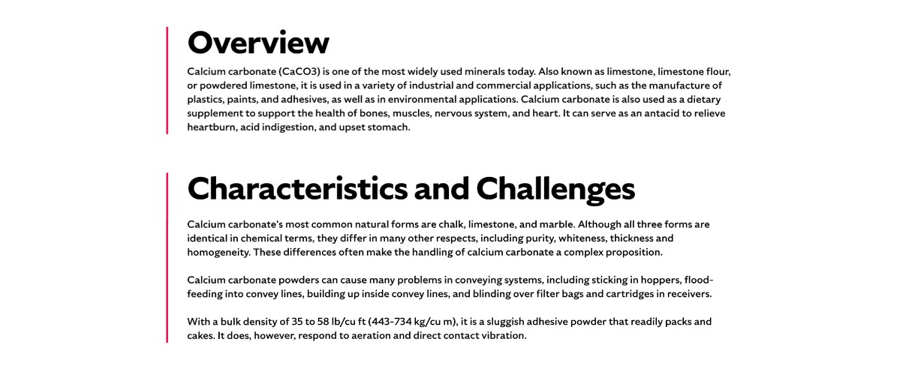

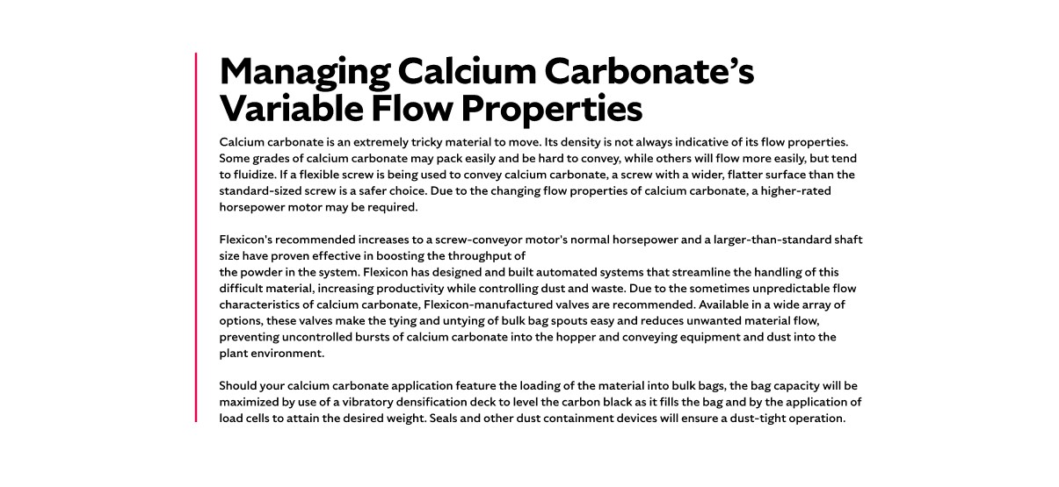

**Overview**Sugar, primarily in the form of sucrose, is derived from sugar cane and sugar beets and is essential in baking, confectionery, and beverage industries. It also plays a role in pharmaceuticals, fermentation, and even industrial applications like concrete bonding. Sugar is available in various forms, including granular and powdered, each with unique handling requirements. Whether you're producing sweet treats or specialty chemicals, sugar’s versatility makes it indispensable across sectors.

**Characteristics and Challenges**Granular sugar is free-flowing, mildly abrasive, hygroscopic, and friable, requiring gentle handling to prevent degradation. Powdered sugar shares its hygroscopic nature but differs in being non-free-flowing, heat-sensitive, and aeratable. It often requires flow-aid devices to maintain consistent movement. Both forms are susceptible to moisture absorption, which can lead to clumping and reduced handling efficiency. Improper conveying of sugar can result in downtime, product loss, and safety risks. Sugar dust suspended in the air is highly explosive, making dust control and proper equipment design essential for safe operation. When sugar is pneumatically conveyed into a processing system, the blower must be appropriately sized to meet system demands. Because sugar absorbs moisture from the air, excessive clumping may occur, requiring humidity control or moisture-removal devices before the sugar enters the conveyor. Temperature regulation through air cooling or heating may also be necessary during conveying.

When sugar arrives in large bulk bags, discharge frames often need additional accessories to fully empty the bags and prevent fine sugar dust from escaping into the surrounding environment. For smaller bags (under 50 lb), a bag-emptying station equipped with a dust hood, filtration system, and pneumatic pulse cleaner can support manual unloading. Some powdered sugars tend to agglomerate, "rat hole," or bridge in hoppers, disrupting material flow. To prevent this, feed hoppers should be designed with appropriate geometry and may require flow-promoting devices such as air fluidizers, vibrators, or mechanical agitators. If sugar is manually dumped into a hopper with agitation equipment, a hopper screen above the receiving vessel can help protect operators. When using a flexible screw conveyor, it’s important to select a screw design that matches the sugar’s properties and application needs—typically one with a wider, flatter surface for conveying sugar up an incline.

**SHELF #2 - FLEXICON SOLUTIONS**

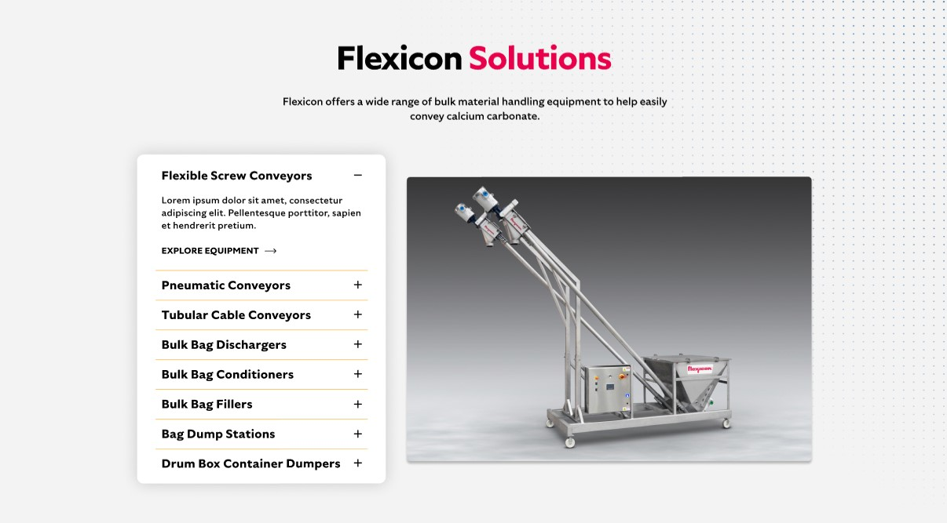

**Flexicon Solutions**

Flexicon offers a wide range of bulk material handling equipment to help easily convey sugar:

* **Flexible Screw Conveyor**: Transport sugar smoothly with minimal product damage or separation.
* **Pneumatic Conveyors:** Fully enclosed systems ensure clean, efficient sugar movement without airborne dust.
* **Tubular Cable Conveyors:** Well-suited for confined spaces, these enclosed systems offer flexible routing for efficient sugar transfer.
* **Bulk Bag Dischargers:** Provide secure and dust-controlled emptying of sugar from large bags.
* **Bulk Bag Conditioners:** Break up hardened sugar to maintain a steady and reliable flow.
* **Bulk Bag Fillers:** Precisely load sugar into bulk bags while keeping dust emissions low.
* **Bag Dump Stations:** Facilitate manual sugar input with built-in dust collection for cleaner operation.
* **Drum/Box/Container Dumpers:** Allow safe and low-dust sugar transfer from smaller packaging with reduced manual effort.

**SHELF #3: LIFETIME PERFORMANCE GUARANTEE**

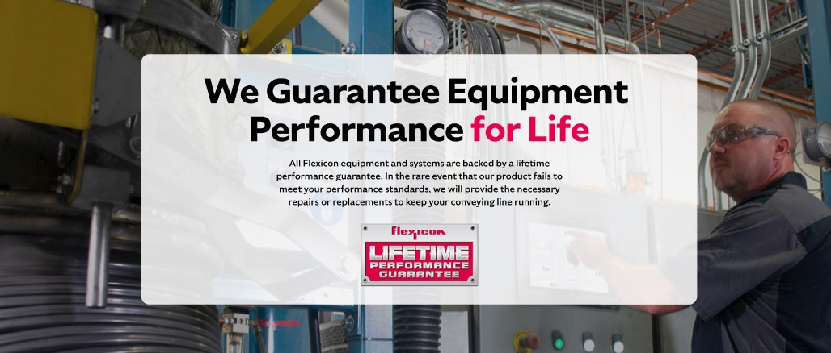

**Lifetime Performance Guarantee**

All Flexicon equipment and systems are backed by a lifetime performance guarantee. In the rare event that our product fails to meet your performance standards, we will provide the necessary repairs or replacements to keep your conveying line running.

**SHELF #4: CASE STUDIES**

